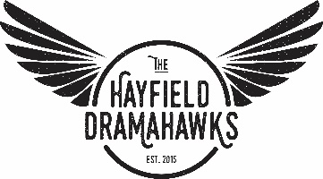

Hayfield Secondary School (Drama Department)
7630 Telegraph Road
Alexandria, VA 22315

Attention Local Business Owners & Supporters of the Arts:

Thank you for your interest in Hayfield Secondary School’s Theatre Arts Show Programs! Your paid advertisements help finance our exciting live productions and support the artistic development of some of the area’s most talented young people - many of whom are probably right in your neighborhood!

Displaying your advertisement in one or more of our show programs will also give you access to valuable customers who are likely to buy your products and services. People love to support local businesses and you are sure to get positive responses from drama students, their friends, parents, relatives and friends of the theatre. The average household income in Hayfield and surrounding areas is $145,000 and people are very enthusiastic about supporting local businesses and retail stores. Don’t miss this great opportunity to reach a valuable customer base for a very modest investment.

We can accept camera-ready ads in the sizes listed on the advertising form. You can choose a full page, half page or quarter page for a specific show during the year or you can place ads in ALL of the shows to receive a special volume discount! You can change your ad design for different performances as your business changes or to emphasize different sales or services. There are 5 shows this year so you will be able to reach thousands of people over the next 10-12 months!

Thank you for choosing to support our young actors, dancers, singers and musicians while also giving your local business or organization additional visibility. We greatly appreciate your sponsorship! Please call or text Steve Miller at 703-298-1446 if you have any questions or need assistance.

Sincerely,

Hayfield Drama Boosters Club

For more information, please text Steve Miller at 703-298-1446!

Also check us out on the web or buy tickets at HayfieldDrama.com!

